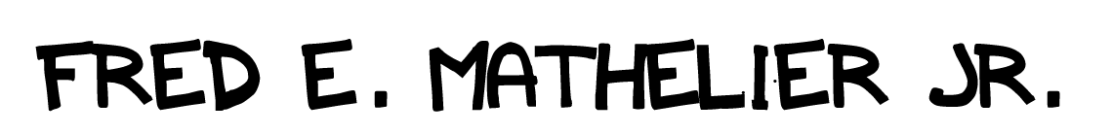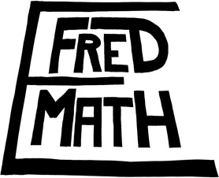

*Drawings that move. Stories with soul.*

**WORK EXPERIENCE:**

**Pencilmation.** Remote — *Storyboard Artist*

MAY 2020 – PRESENT

* **Storyboard Artist**: *Pencilmation*
  + Storyboard Artists on Pencilmation work within a remote production environment, requiring strong communication skills and deadline management

**Titmouse Inc.** NYC — *Art Intern*

JUNE 2019 – SEPTEMBER 2019

* **Cleanup Artist**: *Ballmastrz9009*
* **Layout Artist**: *Midnight Gospel*
  + The NYC Titmouse Internship is the definition of a fast-paced frenetic production-based environment. Interns require strong organization skills, and provides experience interacting with employees at all levels

**Brown Motion Pictures.** Providence — *Animator*

DECEMBER 2019 – JANUARY 2020

* **Character Animator**: Wilt
  + Working freelance requires effective time management

**RISD Film/Anim./Video Dept.** Providence RI — *Teaching Aid*

SEPTEMBER 2017 – MAY 2020

**RISD Writing Center (Center for Arts & Language),** Providence RI — *Tutor*

SEPTEMBER 2017 - PRESENT

**RELEVANT COURSEWORK:**

**2D Character Animation | Storyboarding |Cartooning**

* **ILLUS-3108: *Artistic Anatomy:*** A fine-tuned ability to draw the human body from any angle, an invaluable when acting through storyboarding or animation.
* **FAV-5130: *Computer Animation:*** Familiar and comfortable with industry standard animation software, character rigging, and compositing.
* **FAV-5108: *Character Animation:*** Confident with posing, character acting, and timing, and thanks to group work, confident when using these skills with a team.
* **LAS-E371: *Environmental Graphic Literature:*** Able to interpret, engage with, and communicate the core of ideas, as well as the tools writers use to express those ideas.

**617.997.3300**

**Fmatheli.myportfolio.com**

**Femathjr@gmail.com**

**SOFTWARE PROFICIENCY**

* Shotgun
* Excel
* Word
* Gmail
* Photoshop
* After Effects,
* Premiere Pro
* Illustrator, Flash/Animate
* Audition
* Harmony
* Storyboard Pro
* Final Draft



*Drawings that move. Stories with soul.*

**DreamWorks Recruitment,**

My name is Fred E. Math and I am a 2020 RISD animation graduate applying to the Animation Internship this fall. I am eager to observe and learn about the animation pipeline and gain insight into production responsibilities, workflows, and processes.

DreamWorks is a company that considers itself and its characters a part of the family, and in my case that would be true. From the 2-D movies like Spirit and Road to El Dorado, to the cultural craze that was Shrek, the imagination igniting world of How to Train Your Dragon, up to today with Kipo and She-Ra, DreamWorks has always packed so much heart and soul into its stories and characters, that my home would be empty without that stack of DVDs in the corner next to the TV, or the Netflix subscription coming in through the Roku. This goes doubly considering DreamWorks’s visible effort to reach out to platform Black creators such as myself, and the LGBT+ creators with which we ally. (Seriously Kipo is my favorite show right now)

I am a 2020 RISD grad with a solid grasp on character animation, storyboarding, and gesture drawing, but my most important asset is my learning mindset. Critique is always an opportunity to grow, and creative guidelines turn my creative passion into a focused effort. I manage my time effectively, meet deadlines consistently, and I like to bake, which makes office potlucks with me just a little bit sweeter, when we aren’t all socially distancing that is. I am a good storyteller, and I believe that shows in the stories I tell (fredemath.com, instagram.com/justbutton).

Thank you for your time! I am available for interview over the phone anytime with a heads-up. I eagerly await speaking further.

Very Respectfully,

Fred E. Mathelier Jr.

**617.997.3300**

**Fmatheli.myportfolio.com**

[**Femathjr@gmail.com**](mailto:Femathjr@gmail.com)